Please Read: We encourage all teachers to modify the materials to meet the needs of their students. To create a version of this document that you can edit:  1. Make sure you are signed into a Google account when you are on the resource.  2. Go to the "File" pull down menu in the upper left hand corner and select "Make a Copy." This will give you a version of the document that you own and can modify. | 

Teacher Overview: How did Christianity impact the lives of Christians living in the Roman Empire?

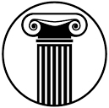 | Unit Essential Question(s): How did classical civilizations gain, consolidate, maintain and lose their power? | Link to Unit
Supporting Question(s):
- How did Christianity form? What are the major beliefs of Christianity? How does Christianity impact the lives of Christians? How did Christianity spread?
Objective(s):
- Describe how the treatment of Christians in the Roman empire changed over time.

Go directly to student-facing materials!

Alignment to State Standards

1. NYS Social Studies Framework:
Key Idea | Conceptual Understandings | Content Specifications
9.2 BELIEF SYSTEMS: RISE AND IMPACT: The emergence and spread of belief systems influenced and shaped the development of cultures, as well as their traditions and identities. Important similarities and differences between these belief systems are found in their core beliefs, ethical codes, practices, and social relationships. (Standards 2, 3; Themes: ID, SOC) | 9.2a Belief systems developed beliefs and practices to address questions of origin, the requirements to live a good life, and the nature of the afterlife.  9.2b Belief systems were often used to unify groups of people, and affected social order and gender roles. | Students will identify the place of origin, compare and contrast the core beliefs and practices, and explore the sacred texts and ethical codes for Hinduism, Buddhism, Judaism, Christianity, Islam, Confucianism, and Daoism.  Students will examine similarities and differences between Hinduism, Buddhism, Judaism, Christianity, Islam, and Confucianism regarding their effects on social order and gender roles.

Social Studies Practices
NYS Social Studies Practices | New Visions Student Social Studies Practices
Gathering, Using, and Interpreting Evidence (A2, A3, A5)  Comparison and Contextualization (C2) |  | Connect Cause and Effect  The act of identifying and explaining the long and short term causes and effects of a historical event.
 |  | Contextualize  The act of describing the geographic, economic, political, and historical circumstances of an event on a local, regional, and global scale.

Common Core State Standards
Depending on how you structure your lesson, you may address different standards. Below, are the standards that we believe are most important for this lesson.
Reading | Writing | Speaking and Listening
Craft and Structure:  CCSS.ELA-LITERACY.RH.9-10.4: Determine the meaning of words and phrases as they are used in a text, including vocabulary describing political, social, or economic aspects of history/social science.  Integration of Knowledge and Ideas:  CCSS.ELA-LITERACY.RH.9-10.7: Integrate quantitative or technical analysis (e.g., charts, research data) with qualitative analysis in print or digital text.  CCSS.ELA-LITERACY.RH.9-10.9: Compare and contrast treatments of the same topic in several primary and secondary sources. | Text Types & Purposes:  CCSS.ELA-LITERACY.WHST.9-10.1: Write arguments focused on discipline-specific content. | Comprehension and Collaboration:  CCSS.ELA-LITERACY.SL.9-10.1: Initiate and participate effectively in a range of collaborative discussions (one-on-one, in groups, and teacher-led) with diverse partners on grades 9-10 topics, texts, and issues, building on others' ideas and expressing their own clearly and persuasively.

Objective: | How did Christianity impact the lives of Christians living in the Roman Empire?  - Describe how the treatment of Christians in the Roman Empire changed over time.

Introduction
➡Directions: Examine the image below and complete the See-Think-Wonder activity to the right.

The image below is a section of a painting that was painted by an artist named Henry Siemiradzki in 1876. It depicts his interpretation of how the Roman Emperor Nero treated Christians.
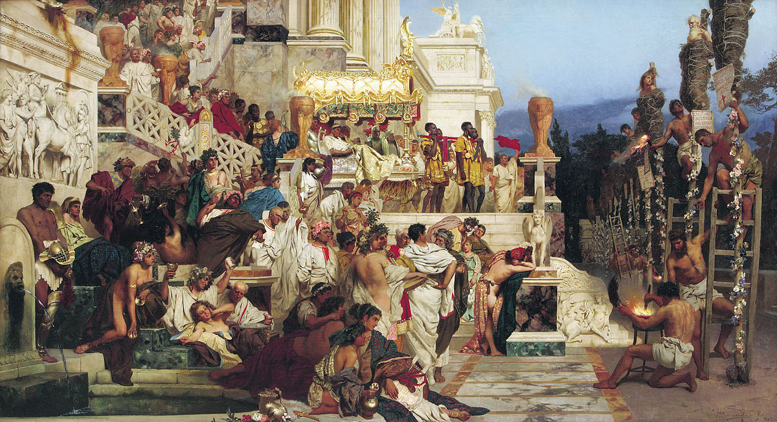  Source: Nero's Torches (Christian Candlesticks) by Henry Siemiradzki, 1876. https://en.wikipedia.org/wiki/File:Siemiradski_Fackeln.jpg | See  List three things you see in the image.
Think
Based on your observations, what do you think the painters claim is?
Wonder
Write two questions you have about the painting.

Contextualize | Timeline of Christianity in the Roman Empire  ➡Directions: Examine the timeline below and answer the questions accompanying it.

edict | an official order | scapegoat | to be unfairly blamed
martyr | a person who is killed because of their religious or other beliefs | persecution | hostility and ill-treatment, especially because of race or political or religious beliefs

30 CE | Crucifixion of Jesus
A generation after the death of Christ, Christianity had reached Rome in the form of a sect of Judaism popular among the city's poor and destitute. Members of this religious sect spoke of the coming of a new kingdom and a new king. These views provoked suspicion among the Jewish authorities who rejected the group and fear among the Roman authorities who perceived these sentiments as a threat to the Empire.
1. After the death of Jesus, how did the Jewish authority perceive the followers of Jesus? Why? | 2. After the death of Jesus, how did the Roman empire perceive the followers of Jesus? Why?

64 CE | 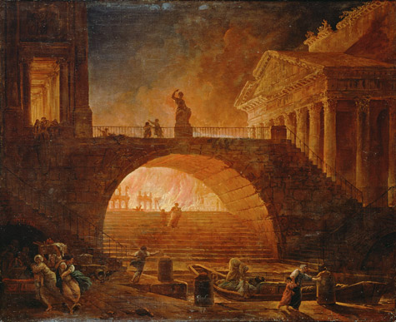  Rome Fire: In the summer of 64 CE, Rome suffered a terrible fire that burned for six days and seven nights consuming almost three quarters of the city. Nero, the emperor of Rome at the time, scapegoated Christians for the fire. The emperor ordered the arrest of members of the sect. As many of the religious sect that could be found were rounded up and put to death and tortured for the amusement of the citizens of Rome. Some were torn apart by dogs, others burnt alive as human torches.  Image Source: http://ngm.nationalgeographic.com/2014/09/emperor-nero/draper-text  3. How did Nero treat the Christians after the fire of 64 CE? Why was this done publicly? 4. What does this treatment reveal about the Roman Empire’s feelings towards followers of Jesus?
60s-300s CE | A Christian martyr is a person who was killed for following Christianity, through stoning, crucifixion, burning at the stake or other forms of torture and capital punishment. The word "martyr" comes from the Greek word mártys, which means "witness." This meant that a Christian martyr was a witness for their religious belief or testified that they were Christian. They endured suffering and/or death for their beliefs. Early Christians martyrs were venerated, or regarded with great respect, and seen as both powerful leaders and examples. Martyrs are often viewed as heroes for their willingness to die for their beliefs.  5. What is a martyr? 6. How were martyrs viewed by other Christians? Why?  ➡ Directions: Examine the image below, then fill out the chart with what you see, think and wonder about the treatment of Christians.  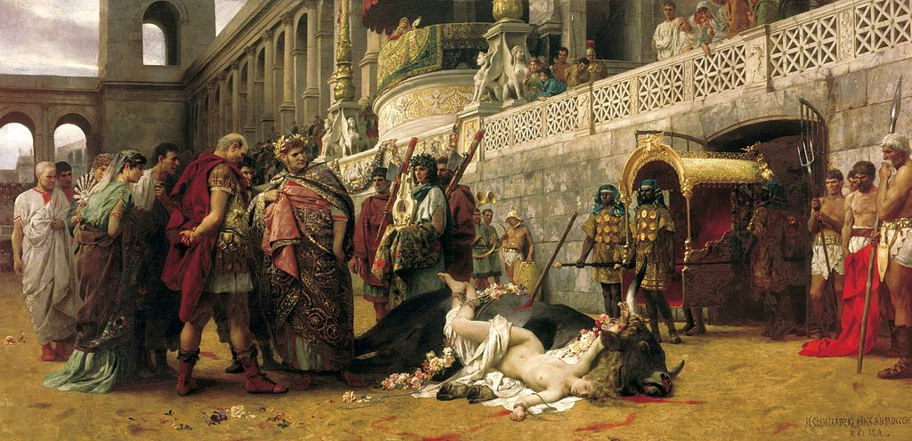  Christian Dirce (Henryk Siemiradzk)i shows the punishment of a Roman woman who had converted to Christianity(1897)  Source: https://en.wikipedia.org/wiki/First_Martyrs_of_the_Church_of_Rome#/media/File:Siemiradzki_Christian_Dirce.jpg  See List three things you see in the image above. Think Based on your observations, how do you think Christians were treated? Wonder Write two questions you have about the image above.  ➡ Directions: Examine the image below, then fill out the chart with what you see, think and wonder about the treatment of Christians.  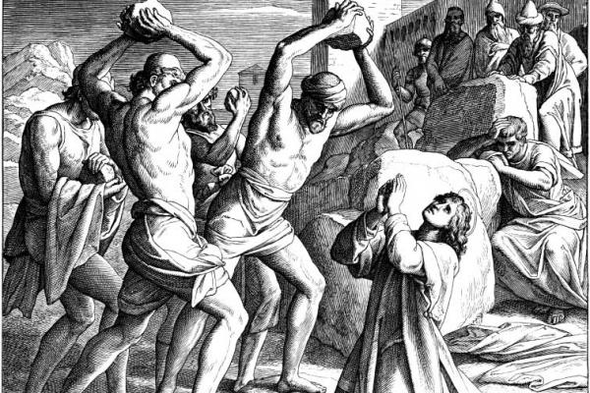  Stephen was an early Christian martyr who is remembered on December 26.  Source: https://en.wikipedia.org/wiki/St._Stephen%27s_Day  Source: https://en.wikipedia.org/wiki/First_Martyrs_of_the_Church_of_Rome#/media/File:Siemiradzki_Christian_Dirce.jpg  See List three things you see in the image above. Think Based on your observations, how do you think Christians were treated? Wonder Write two questions you have about the image above.  How did martyrdom impact the growth of the Christian Church?  Quintus Septimius Florens Tertullianus (Father Tertullian) (155-240 CE) was a prolific early Christian author from Carthage in the Roman province of Africa. Apologeticus, published around 197 CE, is Tertullian's most famous work where he demanded legal toleration and that Christians be treated as all other sects of the Roman Empire. Below is an excerpt from Chapter 50 of Apologeticus.  Direction: Read the excerpt below and respond to the questions.  Nor does your [Roman] cruelty, however exquisite, [help] you; it is rather a temptation to us. The oftener we are mown [cut] down by you, the more in number we grow; the blood of Christians is [the] seed [of the Church]. [...] On this account it is that we return thanks on the very spot for your sentences. As the divine and human are ever opposed to each other, when we are condemned by you, we are acquitted by the Highest.  Source: http://www.ccel.org/ccel/schaff/anf03.iv.iii.l.html, https://books.google.com/books?id=NLhdW4V94zwC  7. What does the sentence, “the blood of Christians is [the] seed [of the Church]” mean?  8. According to this excerpt from Tertullianus, how does the killing of Christians impact the growth of the Church?
249-251 CE | Some accounts of Christian persecutions say that believers were thrown to wild animals in Roman amphitheaters—as depicted in this 19th century painting. Source: http://www.nationalgeographic.com/lostgospel/timeline_09.html Starting in 60 CE, there was a long period in which the persecution of Christianity was inconsistent and local. In the middle of the 3rd century, Emperor Decius decided that Christians were a real enemy of the Roman order and stability. As such, Emperor Decius required all Christians to not only to offer sacrifice to Roman gods, but also to obtain official certificates from witnesses to their offering.  9. How did Emperor Decius requirement affect Christians?  10. Why did he try to enforce this requirement?
313 CE | Edict of Milan: The emperor Constantine I converted to Christianity in 312. In 313, Emperor Constantine outlawed religious persecution in the Roman empire. The edict granted all persons freedom to worship whatever deity they pleased. It also promised Christians legal rights and the right to organize churches.  How did the Edict of Milan affect Christians?
380 CE | Edict of Thessalonica: Emperor Theodosius I made Christianity the state church of the Roman Empire and made it the Empire's sole authorized religion.  How did the Edict of Thessalonica affect Christians?
Source: http://www.nationalgeographic.com/lostgospel/timeline_09.html, http://www.pbs.org/wgbh/pages/frontline/shows/religion/why/martyrs.html

Contextualize | - According to the timeline, how did the treatment of Christians change over time?  - According to the timeline, how did Christianity divide the Roman empire?  - According to the timeline, how did Christianity unify the Roman empire?

FA | SQ 28: How did Christianity impact the lives of Christians living in the Roman Empire?  ➡ Directions: Use the information you learned about Christianity to complete the tasks below. Use the Belief Systems Chart to keep track of this information.
 | Describe how the treatment of Christians in the Roman empire changed over time.

